LPE2504 CREATIVE WRITING SKILLS
SEMESTER 1 – 2025/2026
LECTURE NOTES 2 – WEEK 3

WEEK 3

THREE-WORD CONVERSATION POEM

A three-word conversation poem is essentially a dialogue between two characters. The first line is spoken by one speaker, and the next line is spoken by the other speaker. It is a conversation between two individuals and has a certain theme or idea.

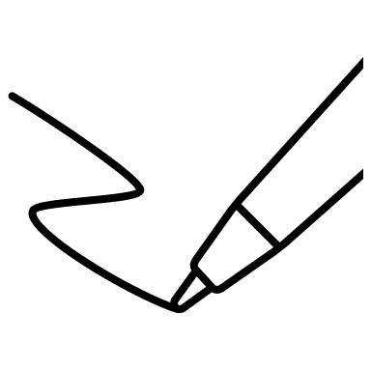
Activity 1

Poem 1
Instructions
Recite the poem below with a partner and answer the following questions.

- Who are the participants?

- What do you think the conversation is about?

- Suggest a possible title for the poem.

- Based on what you have learned till now, what do you notice about the structure of the poem?

Untitled

When’s our wedding?
I’m not sure.
Not yet decided?
No. Not yet.
Then I’ll leave.
No. Please don’t.
So when then?
Um… Next year.
Too late. Bye!

Poem 2
Instructions
Recite the poem below with a partner and answer the following questions.

- Who are the participants?

- What do you think the conversation is about?

- Suggest a possible title for the poem.

- Based on what you have learned till now, what do you notice about the structure of the poem?

Untitled

What is this?
I don’t know.
Who sent it?
Read the label.
Seen my glasses?
On the fridge.
Get them, please.
Get them yourself.
Why so rude?
Why so bossy?

 Notes
- A three-word conversation poem is basically a chat between two individuals.
- The poem itself does not have to rhyme but it can be added to provide a rhythmic or musical element.
- Each line consists of just three words.
- The words chosen will reflect the theme or idea of the poem.
- The number of lines is only limited by the writer’s imagination. However, you may follow as instructed by the given assignment for this course.

Discussion

- How different is a three-word conversation poem with other poems you have read before?

- How do you feel about the way the poem is written?

Activity 2

Fill in the blanks to complete the following three-word conversation poems.

- The Unfamiliar Friend

______ ______ ______
Who is that?
______ ______ ______
But you should.
______ ______ ______
Because you should.
______ ______ ______
What’s your name?
______ ______ ______

- What am I?

______ ______ ______
That’s a cat.
______ ______ ______
It’s a dog?
______ ______ ______
That’s a bird.
______ ______ ______
Bee it is.
______ ______ ______
They all left.
- At the Zoo

______ ______ ______?
At the zoo.
______ ______ ______?
To see animals.
______ ______ ______?
The mighty lion.
______ ______ ______?
I’m not tired.
______ ______ ______?
Not now, nope.
______ ______ ______?
I’m happy here.

- My Terrible Nightmare

What’s wrong Lim?
______ ______ ______.
What’s it about?
______ ______ ______.
Did you see?
______ ______ ______.
Was it scary?
______ ______ ______.
Tell me more.
______ ______ ______.
Oh my god!
______ ______ ______.


Activity 3
Part 1
- Get into pairs.
- Choose one of the topics below and write a 7 – 8 line Three-word Conversation Poem.
- Include the use of literary devices in your poem. Underline the literary devices.

Suggested topics
Shopkeeper to customer | teacher to student | husband to wife | driver to police officer | boy to girl
editor to author | actor to director | lizard to worm | snake to snake | clown to a small child

Part 2

- Read out and perform your Three-word Conversation Poems from Part 1.
- Receive feedback or comment on your work.

Suggested general feedback guide:
- Who are the participants in the conversation?
- What is the conversation about?
- What is the message of the poem?
- Structure: Does the poem follow the required structure? (i.e., 7 – 8 lines Three-word Conversation Poem).

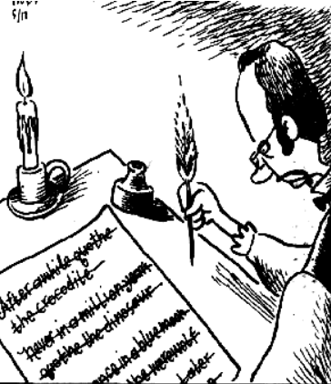

ACROSTIC POEM

An acrostic poem is a type of poem in which the first letter of each line, when read vertically from top to bottom, spells out a word, message, or name. Each line in the poem typically begins with the corresponding letter of the word or message being spelled out.
Acrostic poems are often used to convey hidden meanings, express emotions, or simply a fun and creative way to write poetry.

Activity 4

Instructions
Recite the 2 poems below with a partner and answer the following questions.

- What do you think the poem is about?

- What is noticed about the words used for the poems: “HOME” and “SPRING”?

- What can be said about the structure of an acrostic poem based on the two examples below?

- Are there any literary devices used in the poems above?

Poem 1 | Poem 2
Home  Open and inviting  Universal  Safe and warm  Everything | Sunny days  Plants awakening  Raindrops on the roof  Interesting clouds  New flowers  Gray skies

Notes
- An acrostic poem or acrostics is basically a poem with each line beginning with an alphabet which reads out a name, an idea, or a concept when read from top to bottom.
- The beginning alphabet could also begin in the middle of the line.
- The poem itself does not have to rhyme but it can be added to provide a rhythmic or musical element.
- The words chosen will reflect the theme or idea of the poem.
- The number of lines is only limited by the writer’s imagination. However, you may follow as instructed by the given assignment for this course.

Acrostic Poems That Spell Names
Composing an acrostic poem using a person’s name can illustrate an individual’s personality (real or otherwise). These are some examples.

SOPHIA
Serene, a calming quality
Organized, you always have it together
Picturesque, strikingly beautiful
Honest, so genuine
Imaginative, a creative mind
Alluring, so attractive

WILLIAM
Worthy, your friendship is a gift
Illustrious, bright, and accomplished
Lively, the life of the party
Light-hearted, you have an easy laughter
Inspirational, the ability to motivate
Approachable, people turn to you for help
Merry, abundant joy

Activity 5
Fill in the blanks with words to complete the following acrostic poems. You may write one word or a short phrase to complete each line. You may also include literary devices.

- C - ________________________________
A - ________________________________
T - ________________________________
S - ________________________________

- F - ________________________________
E - ________________________________
A - ________________________________
R - ________________________________

- G - _________________________________
O - _________________________________
A - _________________________________
L - _________________________________

- H - __________________________________
A - __________________________________
P - __________________________________
P - __________________________________
Y - __________________________________



Activity 6

Rewrite an acrostic poem to convey the opposite meaning. This can be shared in class.
Funny  Real  Interesting  Enjoyable  Nice  Delightful | Foolish  Rude  Insolent  Egoistical  Naughty  Desperate
Home  Open and inviting  Universal  Safe and warm  Everything | H___________  O___________  U___________  S___________  E___________
Sunny days  Plants awakening  Raindrops on the roof  Interesting clouds  New flowers  Gray skies | S___________  P___________  R___________  I___________  N___________  G___________



Activity 7
This is an in-class activity.
- You are given 15 minutes to write an acrostic poem based on the alphabets of your name.
- Include the use of literary devices in your poem. Underline the literary devices.

Suggested general feedback guide:
- What is the message of the poem?
- Structure: Does the poem follow the required structure? (i.e., acrostic poem based on the alphabets of students’ name).

Part 2

- Read out and perform your acrostic poem from Part 1.
- Receive feedback or comment on your work.

Suggested general feedback guide:
- What is the message of the poem?
- Do the words chosen reflect the individual named?
- Structure: Does the poem follow the required structure? (i.e., acrostic poem based on the alphabets of students’ name).

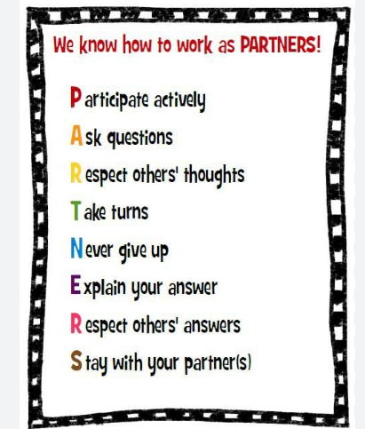

Summary

A poem can be both playful and thought provoking. They do not have to be written using difficult words or have a typical poetic structure as illustrated by the 3-word conversation poem and the acrostic poem (or acrostics).
A 3-word conversational poem is a form of creative writing that describes a thematic dialogue between two individuals using just 3 words in a line where message and emotions are conveyed through clever use of short or concise words.
An acrostic poem (or acrostics) is another form of creative writing that uses the first alphabet of a concept, idea, phenomenon or even the name a person to emphasise the meaning or qualities of the chosen theme.

